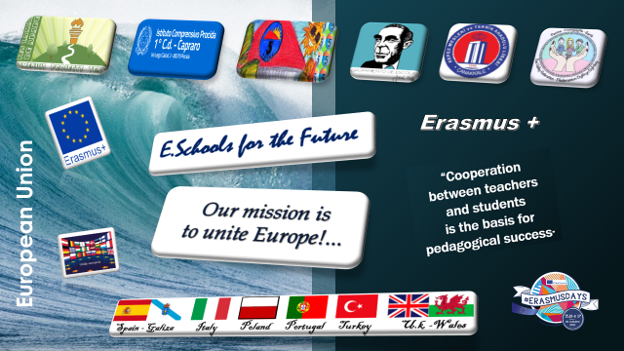

**Neverending Story**

**Poland – Italy – Portugal -Spain**

March 2021

New Life on Earth

Poland

By us

The kids



It was a beautiful and starry day on planet Polus. Paul and Polly were In the playground, when the deadly asteroid hit their world. Lots of people and creatures were scared. Kids left their homes and flew to Earth. Children didn’t like the idea of the trip to a new planet. The Flight was very fast. A few minutes later they landed in a Completely different place.

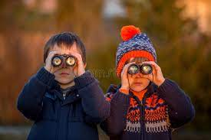

Italy

Once they landed on the new planet Paul and Polly were amazed and surprised to see where they had arrived.

They were intrigued by the new traditions that they will soon know, so they decided to explore the land.

Portugal

Our boys started with the European Union, because they heard rumors that these were beautiful places. They saw the Eiffel tower, the grand Bazaar, the coliseum of Rome and a lot of castles. They also ate the most wonderful things they've ever eaten in life. It was like a dream. And they met many different people from Europe. It was an adventure that never ended!

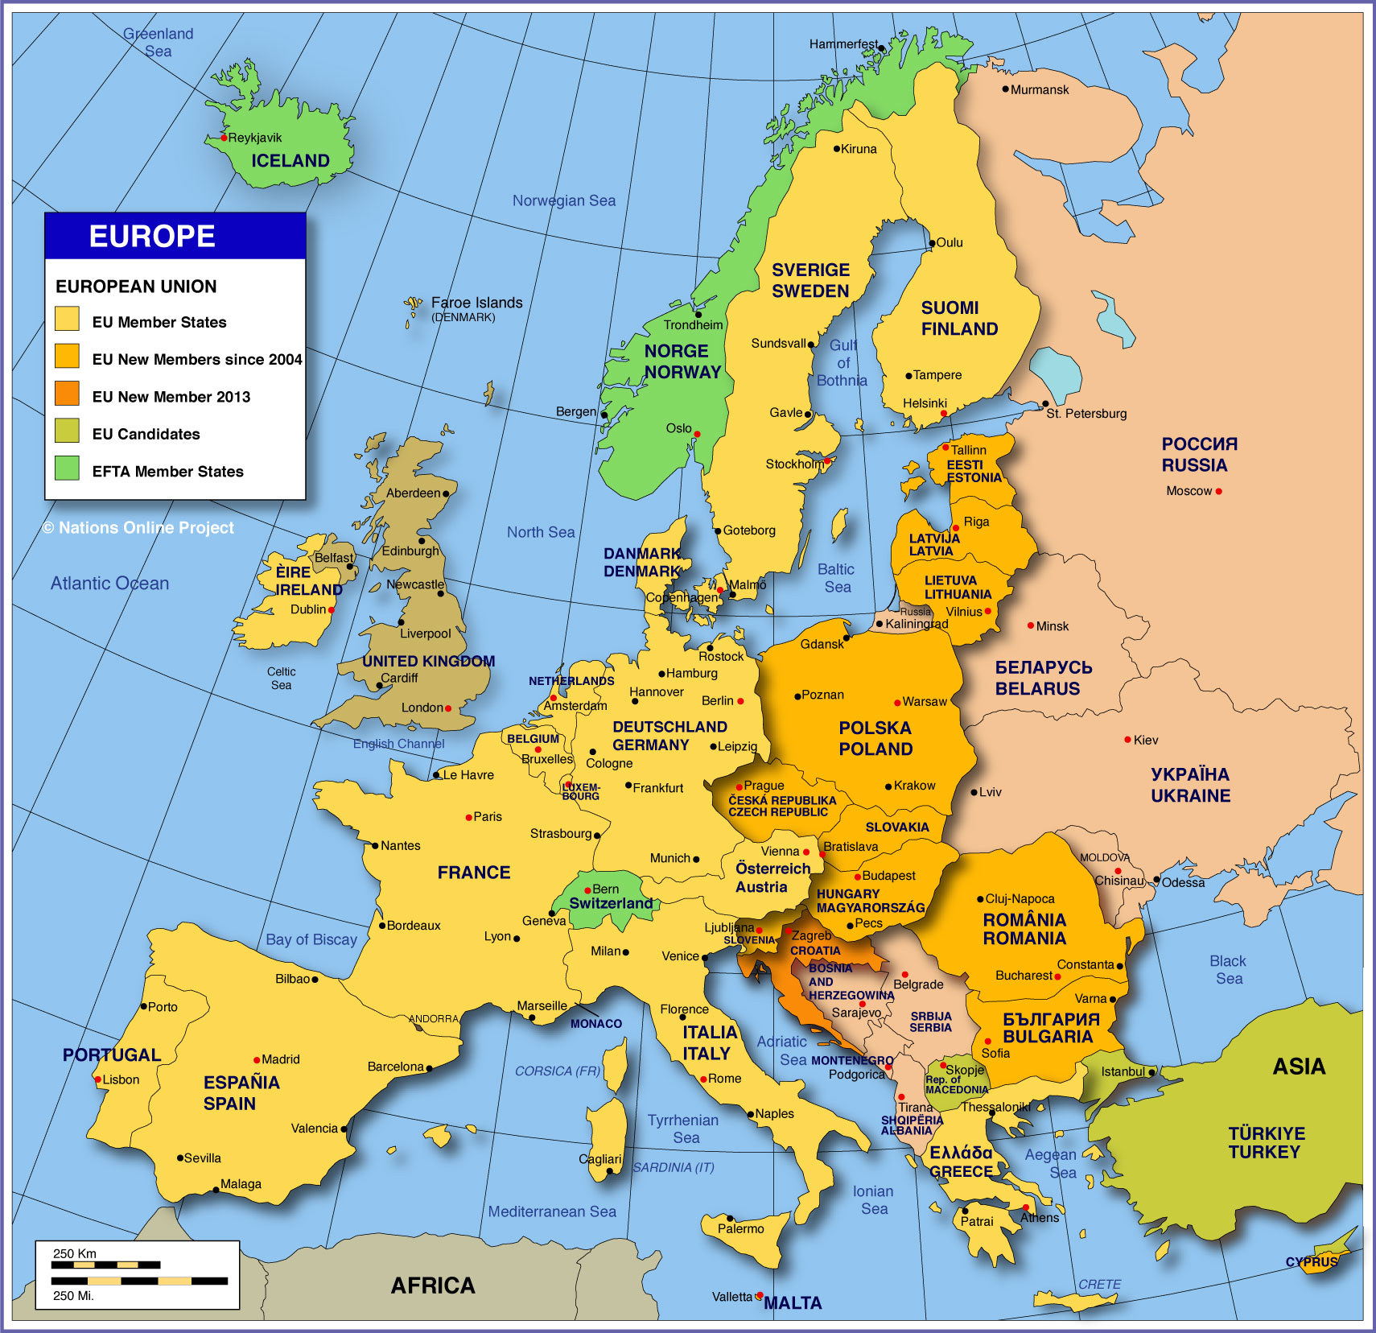

POLAND

After a long journeys they decided to settle somewhere. They chose the country which will be the most comfortable to visit the rest of Europe - Poland. Definitely they voted on this country, because there are tasty dishes for example. Duplings , pork chops and chicken soup. They thought about the choice for long time until they met grandmother. She took care of them , made them dinners, showed traditions and read them books about Poland. (Portugal !!!!! ☺ Polly is a girl ,)

Poland woos voters with controversial child benefit schemehttps://s.france24.com/media/display/68522b0a-7708-11e9-b362-005056bff430/w:980/p:16x9/main_poland-map.webp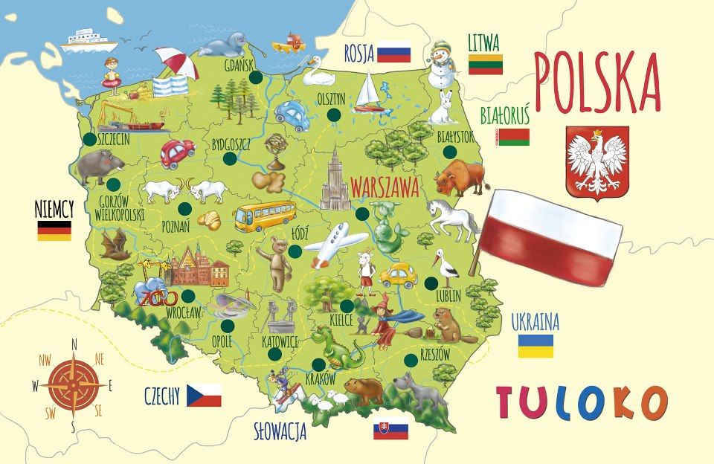

ITALY

Some books talked about adventures at sea so Paul and Polly decided to take a

boat and go to discover the under water world. They encountered fish, dolphins,

fin whales and sea turtles and when they dived, discovered the beautiful coral

reefs. They arrived as far as Italy where they landed on a small island in the

Mediterranean called Procida where they rediscovered its beauties and flavors

such and they tasty pizza and went in search of shells to make a gift to their

grandmother.

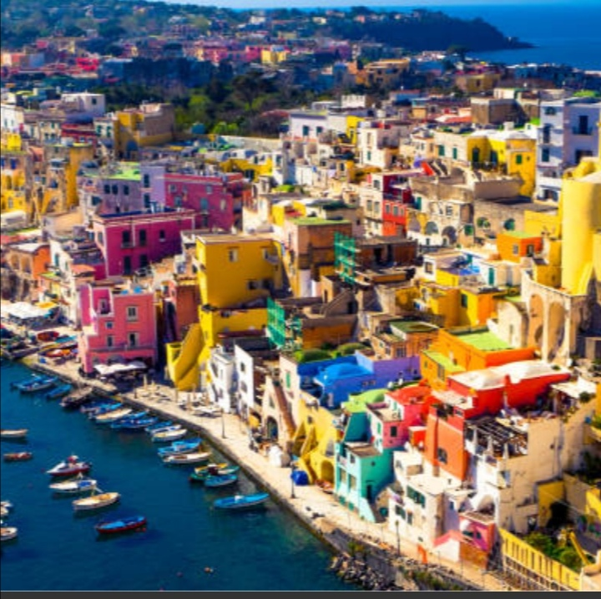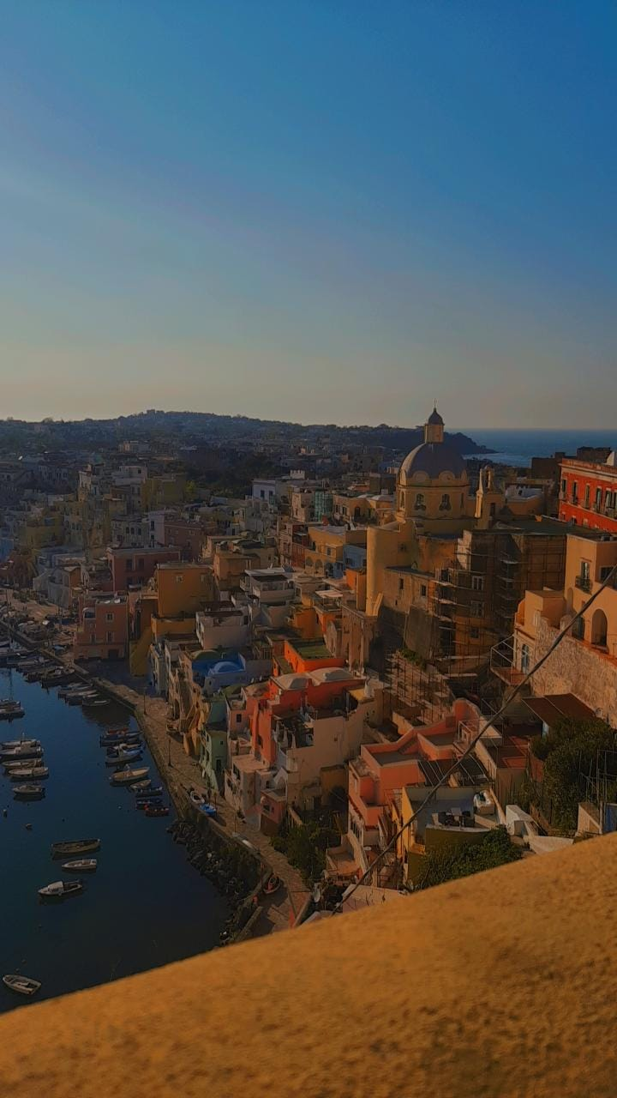

SPAIN

Paul and Polly took a boat and arrived in Andalusia to start the *Camino de Santiago* (also known as the Way of St. James) by the *Via de la Plata*. After 20 days of pilgrimage, they arrived in Lugo, where they walked along the wonderful Roman Wall. Paul and Polly spent two days visiting the city and they got to know the culture and enjoyed its gastronomy with traditional dishes such as *pulpo á feira*.

After the short stay in Lugo, they continued their pilgrimage towards the capital of Galicia and, after passing through Mount Viso in Sar, arrived in Santiago de Compostela.

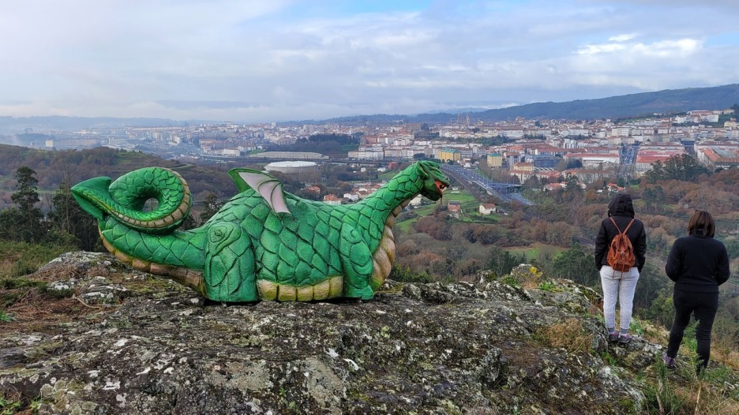

Then, they went to collect the *Compostela* at the Pilgrims’ Office in the old historic city area, where they appreciated the architecture and, of course, its most famous landmark, the Cathedral. Paul and Polly decided to take a lot of pictures to send their grandmother.

